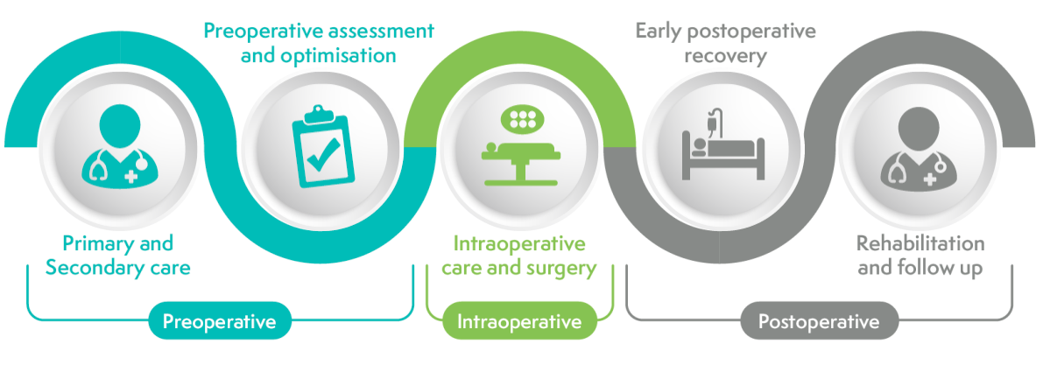

**1. Shared decision making**

**3. Early planning and practical preparation**

**4. Promoting DrEaMing**

**5. Setting expectations**

**6. Early review of planned discharge location**

**7. Patient education and empowerment**

**8. Criteria-led discharge**

**9. Safe transition of care**

**2. Active preparation and optimisation**

**Pre-operative**

**Theme 1: Shared decision making**

|  |  |  |
| --- | --- | --- |
| **Ask** | GP / primary care team at referral (or admitting team if emergency surgery) | **About the patient**   * **Who** they live with? * **What** caring responsibilities? * **Where** they live (e.g., own home, hostel, sheltered accommodation, residential home, nursing home)? * **When**/if need support with ADLs?* * **Why** need support? * **How** coping currently?   *ADLs = activities of daily living |
| Surgical team (doctors/CNS) corroborate at OPD (or as inpatient if emergency surgery) |
| MDT corroborate at high-risk clinic |
| Pre-op practitioner corroborate at POA |
| **Do Is It Just Me Or...?: 10 Thoughts that Constantly Go Through a List ...** | GP / primary care team at referral (or admitting team if emergency surgery) | **Share information**  As a minimum include following on referral to inform shared decision-making conversations   * Place of residence (e.g., own home, hostel, sheltered accommodation, residential home, nursing home) * If patient lives alone or with others * Absence/presence of formal care package   Ideally also include:   * Any informal care or support * [Frailty score](https://www.bgs.org.uk/sites/default/files/content/attachment/2018-07-05/rockwood_cfs.pdf) * Comorbidities * Any ACD, ADRT, DNAR or LPA for health*   *ACD = advanced care directive  ADRT = advance decision to refuse treatment  DNAR = do not attempt resuscitation  LPA = lasting power of attorney |
|  | | |
| **Ask** | Surgical team (doctors/CNS) at OPD (or as inpatient if emergency surgery) | **About what is important**  Find out from the patient what is important to them - their values, beliefs, preferences and goals  Use this information, the frailty score and referral letter information to inform [shared decision-making](https://cpoc.org.uk/shared-decision-making) discussions  It can be helpful to consider   * What are the **benefits**? * What are the **risks**? * What are the **alternatives**? * What if they **do** **nothing**? |
| MDT at high-risk clinic |
| Pre-op practitioner at POA |
| **Do** Is It Just Me Or...?: 10 Thoughts that Constantly Go Through a List ... | Surgical team (doctors/CNS) at OPD (or as inpatient if emergency surgery) | **Set expectations**  **Check that outcome of surgery matches patient’s expectations**  Signpost to any surgery specific patient education e.g., virtual / in person surgery schools, videos, patient leaflets  Provide patient (and carer) with realistic information about   * Suitability for daycase * If inpatient, anticipated length of stay * Anticipated timescales for cognitive, functional and psychological recovery * Anticipated temporary, or permanent, increase in care needs post-operatively * Anticipated temporary, or permanent, restrictions on health or lifestyle   Communicate these expectations to wider healthcare team to ensure consistent messaging |
| MDT at high-risk clinic |
| Pre-op practitioner to reinforce at POA |
| Clinical Nurse Specialist to reinforce at surgery school |

**Theme 2: Active preparation and optimisation**

|  |  |  |
| --- | --- | --- |
| **Do**Is It Just Me Or...?: 10 Thoughts that Constantly Go Through a List ... | **Everyone** to make every contact count | **Encourage active preparation**  Active preparation rather than passive waiting can improve patient outcomes, shorten length of stay by 1-2 days and reduce complications by up to 50%.  Encourage patients to adopt small [lifestyle changes](https://cpoc.org.uk/guidelines-and-resources/perioperative-optimisation-Top-seven-interventions) related to:   * Smoking cessation * Alcohol moderation * Physical activity and exercise * Weight management and nutrition * Mental wellbeing   Signpost patients to resources to prepare for potential elective surgery   * Things to ask, think about and do if you might be having an operation [add link once live] * [FitterBetterSooner](https://www.rcoa.ac.uk/documents/fitter-better-sooner/introduction) (in 25 languages) * [CPOC](https://cpoc.org.uk/patients) * [Add to your life](https://addtoyourlife.nhs.wales/) (NHS Wales) |
| GP / primary care team at referral |
| Surgical team (doctors and CNS) at OPD |
| MDT at high-risk clinic |
| Pre-op practitioner at POA |
| Clinical Nurse Specialist at surgery school |
| **Thinking Concept Cloud Icon. Set Icons in Color Circle Buttons Stock ...Think** | Surgical team (doctors and CNS) at OPD | **About prehabilitation**  Specialist prehabilitation can increase preoperative fitness and reduce complications, length of stay and readmissions.  Is the patient eligible for specialist prehabilitation service (where service is available)? |
| MDT at high-risk clinic |
| Pre-op practitioner at POA |
|  | | |
| **Thinking Concept Cloud Icon. Set Icons in Color Circle Buttons Stock ...Think** | GP / primary care team at referral | **About optimisation**  The sixth key component of active preparation is [assessment, optimisation and shared decision making](https://cpoc.org.uk/guidelines-and-resources/perioperative-optimisation-Top-seven-interventions/assessment-optimisation-sdm)  Is there scope to optimise medication? [STOPP/START review](https://www.england.nhs.uk/wp-content/uploads/2017/03/toolkit-general-practice-frailty-1.pdf) (page 17-20)  Is there scope to optimise comorbidities?   * [Diabetes](https://cpoc.org.uk/guidelines-and-resources/guidelines/guideline-diabetes) * [Anaemia](https://cpoc.org.uk/guidelines-and-resources/guidelines/anaemia-perioperative-pathway) * Hypertension |
| Surgical team (doctors and CNS) at OPD |
| MDT at high-risk clinic |
| Pre-op practitioner at POA |
| **Thinking Concept Cloud Icon. Set Icons in Color Circle Buttons Stock ...Think** | Surgical team (doctors and CNS) at OPD | **About frailty**  Patients living with [frailty](https://www.cpoc.org.uk/sites/cpoc/files/documents/2021-09/CPOC-BGS-Frailty-Guideline-2021.pdf) have a 4-fold increased risk of post-operative complications  If [clinical frailty score](https://www.bgs.org.uk/sites/default/files/content/attachment/2018-07-05/rockwood_cfs.pdf) ≥ 5 think about, or check If had, referral to perioperative frailty team, for comprehensive geriatric assessment (or use [frailty intervention tool](https://cpoc.org.uk/sites/cpoc/files/documents/2021-09/CPOC-BGS-Frailty-Guideline-2021.pdf) [page 23-25], if no perioperative frailty team) |
| MDT at high-risk clinic |
| Pre-op practitioner at POA |

**Theme 3: Early planning and practical preparation**

|  |  |  |
| --- | --- | --- |
| **Thinking Concept Cloud Icon. Set Icons in Color Circle Buttons Stock ...Think** | **Elective:** Pre-op practitioner at POA | **About home care**  Consider how patient will manage at home after operation   * Is patient currently independent? * If not, do they have informal support or formal care? * How are they coping currently? * Is there a support network to provide additional help in postoperative period? * If daycase surgery planned – is a named adult available for 24 hours after surgery? |
| **Emergency surgery:** nursing team on admission ward |
| **Do**Is It Just Me Or...?: 10 Thoughts that Constantly Go Through a List ... | Surgical team (doctors and CNS) at OPD (or as inpatient if emergency surgery) | **Encourage practical preparation**  The seventh, and final, key component of active preparation is practical preparation.  Encourage patients to think about how they will cope with ADLs such as washing and toileting, dressing, mobilising, shopping, meal preparation, housework and transportation post-discharge.  Signpost patients (and carers) to [our resources](https://www.cpoc.org.uk/guidelines-and-resources/perioperative-optimisation-Top-seven-interventions/practical-preparation) or procedure specific resources. |
| MDT at high-risk clinic |
| Pre-op practitioner at POA |
| Clinical Nurse Specialist at surgery school |
| **Ask** | **Elective surgery:** Pre-op practitioner at POA | **About transport**  Ask the patient (or carer)   * How will you get to hospital for operation? * How will you get home when discharged? |
| **Emergency surgery:** nursing team on admission ward |
|  | | |
| **Do** Is It Just Me Or...?: 10 Thoughts that Constantly Go Through a List ... | **Elective surgery:** Pre-op practitioner at POA | **Escalate**  Escalate any anticipated complex discharges (e.g., patients with no fixed abode, patients with anticipated significant change in care needs requiring new social services input) to matron / discharge team lead / homeless coordinator (so discharge planning can start before admission)  Consider delaying routine elective surgery until clear discharge plan agreed. |
| **Emergency surgery:** nursing team on admission ward |

**Early post-operative period**

**Theme 4: Promoting DrEaMing**

|  |  |  |
| --- | --- | --- |
| **Do**Is It Just Me Or...?: 10 Thoughts that Constantly Go Through a List ... | Surgeon in theatre | **Be clear with handover**  Drinking (free fluids), eating (soft diet) and mobilising (from bed to chair) within 24 hours of surgery reduces length of stay by 37.5%[1](https://cpoc.org.uk/updated-dreaming-cquin-2324-1)  Despite the clear benefits, research indicates 30% of patients do not do all three within 24 hours of surgery[2](https://pqip.org.uk/FilesUploaded/PQIP-Report2023-2024.pdf).  Clearly document on operation note/ in medical notes and verbally handover to recovery staff (who can then verbally handover to ward team)   * When patient can resume drinking * When patient can resume eating * Any restrictions on intake (e.g., soft diet) * Any restrictions on mobilising. For orthopaedic surgery: use standard terminology e.g., [non weightbearing, limited weightbearing or unrestricted weightbearing](https://www.boa.ac.uk/resource/mobilisation-and-weightbearing-after-orthopaedic-surgery-musculoskeletal-injury-boast.html)   On handover at start of shift ask:   * Has patient been DrEaMing? * Are there any restrictions on drinking or eating? * Do they need any assistance with feeding? * For orthopaedic patients: what is the weight-bearing status ([non/limited/unrestricted weight-bearing](https://www.boa.ac.uk/resource/mobilisation-and-weightbearing-after-orthopaedic-surgery-musculoskeletal-injury-boast.html))? |
| Recovery staff on ward handover |
| Ward team (nursing and HCSW) on shift handover |
| **Thinking Concept Cloud Icon. Set Icons in Color Circle Buttons Stock ...Think** | Surgical team (doctors and CNS) | **About barriers to mobilising**  Consider potential barriers to mobilisation   * Clearly document plan in notes (including weight bearing status for orthopaedic patients) to remove uncertainty * Document reasons for not removing catheters, drains and drips (which impede mobilisation) * Review pain scores and analgesia * Use and share knowledge of how to support a patient to safely mobilise (*see below*) * Consider patient’s emotional needs (*see below*) |
| Ward nurses |
| Therapies team |
| **Is It Just Me Or...?: 10 Thoughts that Constantly Go Through a List ...Do** | Ward nurses (supported by HCSW) | **Support safe mobilisation**  It is **not** necessary to wait for physiotherapy assessment before encouraging a patient to mobilise after surgery.  Consider the following:   * Does the patient have their glasses and hearing aids (*if applicable*)? * Do they have well-fitting slippers or shoes? * Is their blood pressure stable? * Have they had analgesia? * Can they follow commands and gestures? * Can they change position in bed? * Can they safely sit on edge of bed? * Can they safely stand upright? * Can they lift one foot off the ground, then the other? * [Give it a go](https://www.cec.health.nsw.gov.au/__data/assets/pdf_file/0006/399687/Give-it-a-Go-Guide-Poster.pdf)   If mobilising out of bed is not possible, consider bed-based exercises to reduce risk of deconditioning. |
| **Thinking Concept Cloud Icon. Set Icons in Color Circle Buttons Stock ...Think** | Ward nurses and HCSW | **About emotional needs**  Some patients find active participation in their recovery empowering, but others feel vulnerable.  Reassurance and consistent messaging may help some patients feel confident and safe, and allow them to actively engage with their post-operative care and recovery.[1](https://www.journalslibrary.nihr.ac.uk/hsdr/GHTY5117) |
| Therapies team |
|  | | |

**Theme 5: Setting expectations**

|  |  |  |
| --- | --- | --- |
| **Thinking Concept Cloud Icon. Set Icons in Color Circle Buttons Stock ...Think** | Surgical team (doctors and CNS) | **About deconditioning**  Hospital admission can lead to functional decline, decreased muscle mass and reduced cognition, especially in elderly patients.  Consider how changes to the ward environment and ethos can prevent deconditioning e.g., [#EndPJparalysis](https://endpjparalysis.org/) |
| Ward nurses (supported by HCSW) |
| **Do**  Is It Just Me Or...?: 10 Thoughts that Constantly Go Through a List ... | Surgical team (doctors and CNS) | **Set progress goals**  Set realistic goals for the patient e.g.,   * Getting washed and dressed in day clothes * Sitting out in a chair for increasing durations, including at mealtimes (unless documented exception) * Mobilising increasing distances, including to the bathroom |
| Ward nurses |

**Rehabilitation**

**Theme 6: Early review of planned discharge location**

|  |  |  |
| --- | --- | --- |
| **Ask** | MDT (surgical team, ward nurses, therapies team, discharge support team) on ward round or board round | **About progress / criteria to reside**  Patient’s time is important, especially for patients anticipated to be in last 1000 days of life[1](https://www.last1000days.com/)  On the ward round or board round, to avoid unnecessary delays to discharge, consider:   * Is the patient meeting progress goals? * What is keeping the patient in hospital? * What is needed for today to be a green day (a day of value, progressing towards discharge) rather than a red day (a day of no value)?[2](https://www.england.nhs.uk/south/wp-content/uploads/sites/6/2016/12/rig-red-green-bed-days.pdf) |
| **Ask** | MDT (surgical team, ward nurses, therapies team, discharge support team) on board round | **About rehabilitation potential**  Discuss rehabilitation potential with MDT at daily board round. Consider:   * Is the patient engaging with therapies and nursing team? * If not, what are the barriers? * How can the barriers be overcome? * Is the patient back to baseline? * If not, are their increased care needs fixed or temporary (i.e., do they have rehabilitation potential?) * Would the patient (and carer) benefit from signposting to resources and / or assessing equipment needs? |
|  | | |
| **Ask** | Ward nurses | **About support networks**  Consider how patient will cope with ADLs (activities of daily living) e.g., washing and toileting, dressing, mobilising, shopping, meal preparation, housework and transportation  Ask the patient:   * Who can support you when you go home from hospital? (if additional support needed consider availability of alternative support networks e.g., voluntary organisations)   Ask the family / friends:   * Are you able, and willing to support when the patient goes home from hospital? * If so, how? * Are there any concerns you have about providing support? |
| Therapies team |
| Discharge support team |
| **Is It Just Me Or...?: 10 Thoughts that Constantly Go Through a List ...Do** | MDT (surgical team, ward nurses, therapies team, discharge support team) on board round | **Review discharge location**  As an MDT, on board round, use the information about:   * progress * fixed or temporary increase in care needs * availability of support networks   to confirm if return to normal place of residence is possible.  Alternatives may need to be considered to prevent unnecessary delay in discharge (see diagram below). |

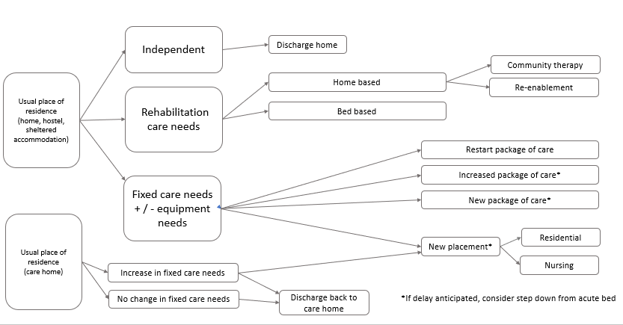

**Discharge**

**Theme 7: Patient education and empowerment**

|  |  |  |  |  |  |  |  |  |  |  |  |  |
| --- | --- | --- | --- | --- | --- | --- | --- | --- | --- | --- | --- | --- |
| **Is It Just Me Or...?: 10 Thoughts that Constantly Go Through a List ... Do** | **Everyone** | **Educate and empower**  Ensure patients (and carers) have sufficient information for safe discharge and feel reassured by:   * providing procedure specific patient information * pre-empting and encouraging questions * explaining who to contact in event of a problem   Consider the following:   |  |  | | --- | --- | | **Surgical team** | Anticipated milestones for recovery  Activities to aid recovery e.g., smoking cessation, weight management or improving nutrition, building up physical activity  Any restrictions on activity e.g., return to work (provide fit note of appropriate duration), driving, flying, heavy lifting  When to seek medical attention  Any need for extended pharmacological thromboprophylaxis  Use of opioid analgesia (including side effects, how to taper dose, safe storage and safe disposal) | | **Nursing team** | Care of any dressings, drains or catheters  How to administer LMWH  Plans for aftercare (e.g., district nurse visits, outpatient appointments) | | **Therapies team** | Exercises to help with recovery  Approaches to managing at home with ADLs | | **Dieticians or nutrition team** | Any dietary restrictions  Care of any enteral feeding tubes | | **Pharmacy team** | Any changes to medication  Any need for extended pharmacological thromboprophylaxis  Use of opioid analgesia (including side effects, how to taper dose, safe storage and safe disposal) | |

**Theme 8: Criteria-led discharge**

|  |  |  |
| --- | --- | --- |
| **Is It Just Me Or...?: 10 Thoughts that Constantly Go Through a List ...Do** | Consultant surgeon | **Adopt criteria led discharge**  Discharge after daycase surgery should be criteria led[1](https://www.gettingitrightfirsttime.co.uk/wp-content/uploads/2024/09/National-Day-Surgery-Delivery-Pack-V2.0-September-2024.pdf), with no minimum time between operation and discharge (except for procedures with risk of haemorrhage)  Discharge criteria:   1. Pain controlled with oral analgesia 2. Nausea and vomiting controlled (or acceptable for transfer home) 3. Patient tolerates oral fluids 4. Patient can mobilise safely 5. Patient has stable observations   The need to pass urine before discharge is only relevant if:   * spinal anaesthesia * urology procedure * gynaecology surgery for incontinence |

**Theme 9: Safe transitions of care**

|  |  |  |
| --- | --- | --- |
| **Do Is It Just Me Or...?: 10 Thoughts that Constantly Go Through a List ...** | Surgical team (doctors and nurse prescribers) | **Discharge prescription**  Communication is essential for patient safety at transfers of care.  The discharge prescription should be a timely written communication with primary care provider which summarises:   * hospital admission * relevant interventions * medication on discharge * next steps   For more information see [here](https://theprsb.org/edischarge-summaries-a-guide/)  Prepare the discharge prescription as soon as possible, ideally the day before discharge. This is especially important if:   * an ambulance is required for discharge * patient usually has their medication in a compliance aid (e.g., blister pack or pillpouch) * medication is being administered via an enteral feeding tube |
| Prompted by ward nurses and discharge support team |
| **Is It Just Me Or...?: 10 Thoughts that Constantly Go Through a List ...Do** | Ward nurses | **Supply equipment**  Assess the need for, and supply, any equipment necessary for discharge e.g., crutches, commode, catheter bags, stoma bags |
| Therapies team |
| Clinical Nurse Specialists |
| **Ask** | Ward nurses and discharge support team | **About transport**  Check with patient (or carer):   * How will they get home (e.g., relative / friend, taxi)? * Do they have a door key? |
| **Do Is It Just Me Or...?: 10 Thoughts that Constantly Go Through a List ...** | Ward nurses and discharge support team | **Share information (with other HCPS)**  Care transitions (e.g., from hospital to home) can be a patient safety risk, especially in those with more complex needs.  To ensure seamless transition of care, ensure relevant information is shared with other healthcare professionals where applicable e.g.   * Ambulance service * District nursing team * Residential or nursing home staff * Specialist services e.g., stoma nurses, palliative care team, anticoagulant service |
| **Do Is It Just Me Or...?: 10 Thoughts that Constantly Go Through a List ...** | Surgical team (doctors and CNS) | **Explain next steps**  Ensure patient (and carer) are aware of any planned follow-up including:   * Removal of sutures / drains * Wound checks * Physiotherapy * CNS or consultant review (if formal follow up is required)   If no formal follow-up required ensure patient (and carer) are aware how to access help if they have concerns e.g.   * Patient initiated follow-up (PIFU) * See on symptoms (SoS) * Primary care consultation |
| Ward nurses |