`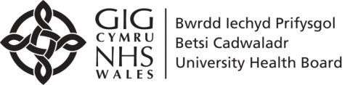  Ysbyty Gwynedd , Bangor | PRE-OPERATIVE ASSESMENT CLINIC (POAC)  CLINIG ASESIAD CYN LLAWDRINIAETH (POAC)  Lead Consultant: Dr C Eickmann Lead Nurse: Anwen Creegan  Lead Pharmacist: Yasmina Hamdaoui  BCUHB – Anaesthetics I 01248 384366
<Insert Date>

Dear Drs at <GP Surgery>

RE: Pre-operative anaemia management:
<Insert Patient Details (Name, DOB, D Number, NHS Number & Address)>

The above patient was seen in Pre-Operative Assessment Clinic (POAC) at Ysbyty Gwynedd.

Following investigations, blood results have indicated that the above patient is iron deficient.

Blood Results on <insert date>

Hb | MCV | MCH | CRP | Ferritin | Transferrin  Saturation | B12 | Folate

In order to optimise the patient for the surgery, we have arranged a prescription for iron supplementation from secondary care:

Ferrous Sulphate 200mg on alternate days (8 weeks supplied)

We would appreciate if you could recheck their blood a month after the commencement of oral iron treatment.

NOTE: <insert as appropriate:
IF NEW: This is a new finding of iron deficiency and the patient was not previously known to be anaemic. Please arrange further investigations and refer as appropriate.
If longstanding anaemia: The cause of this anaemia may remain unclear and may warrant further investigation by yourself. >

Yours Sincerely

POAC Pharmacist

