

PERIOPERATIVE CARE
CASE STUDY SUBMISSION FORM

Contact Details

Your full name:
Title:
Job role:
Email address:
Telephone number:

Case Study Details

Country: | England Northern Ireland Scotland Wales
Hospital/Trust/Healthboard:
Suggested case study title:
POM pathway stage:  (double click box on right) | Before surgery Surgery specific initiatives After surgery  Specific Patient groups Perioperative pathway and team working
Specialty in focus: | Anaesthesia Surgery Nursing General Practice Physicians
Perioperative care themes covered in this case study: (double click box on right) | Improving quality of care Empowering patients and carers  Supporting our workforce Influencing policy Technology and digital  Shared decision-making Day surgery Research and innovation  Perioperative care pathways and outpatients Other
 | If ‘Other’, please provide more detail:

Please Note
By completing this form, you are consenting to the supplied information (excluding contact details) being:
- published on websites for CPOC and its multi-disciplinary partners
- shared publically on social media channels
- shared with UK and international media outlets
- shared within CPOC promotional materials.
Please complete page 2 of this form>>

Tell us your perioperative care story (boxes will expand as you type)
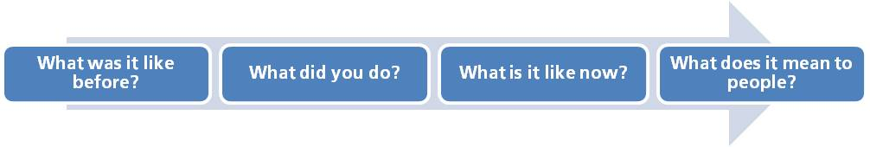
What was the problem/issue (and how was it established that there was a problem)? Numbers of patients impacted?
What solutions were identified and why were they chosen?
What barriers/enablers did you encounter in trying to implement a solution?
Were the solutions supportive of multi-disciplinary working, and if so, how?
What evidence (qualitative or quantitative) is there to demonstrate impact (either positive or negative) on:
- patient outcomes
- patient experiences
- health economics (e.g. reduction in referral times or hospital bed days).
Were patients engaged and consulted? Did the engagement demonstrate shared decision making?
How does the solution relate to or support wider NHS/ government policy in practice, e.g. the NHS Long Term Plan for England/People Plan (and across the devolved nations)?
What learning was developed? How was that learning shared and to whom?
How does the solution support Integrated Care Systems/Partnerships and Primary Care Networks?

Who can we interview? (add more rows if necessary)
Name | Role  (e.g. clinician/patient) | Telephone | Email

Suggestions for potential visual/photo opportunities:

Additional comments:

Please return this form to cpoc@rcoa.ac.uk

